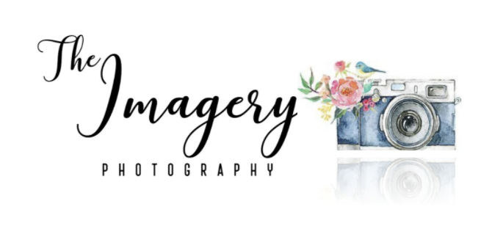

CLIENT PHOTO RELEASE FORM

I hereby grant permission to The Imagery, and it’s photographers to use photographs and/or video of me/us taken on ____________________ in publications, news releases, online, and
in other communications related to the mission of The Imagery.

(Signature of Adult, or Guardian of Children under age 18)

Children’s Name(s) and ages:____________________________________________________

____________________________________________________

____________________________________________________

____________________________________________________

____________________________________________________

Address:_____________________________________________________________________

Phone:______________________________________________________________________

Email Address:________________________________________________________________

Thank you!
The ImageryPhotography
How to contact us:

Photographers: Sharon Sylvester 586-703-4427
Shannon Sylvester 586-980-2271

Email: TheImageryPhotography@gmail.com
Website: https://www.theimagery.org

